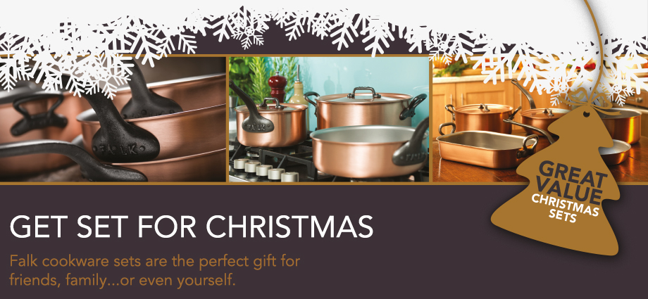

Watch any television cookery show, visit any professional kitchen or walk around any department store and you're likely to spot a vast collection of gleaming copper pans perfectly displayed according to size.

Family owned and operated for three generations, Falk Culinair is a company that embodies the perfect balance of old world craftsmanship with the latest cutting edge technology.

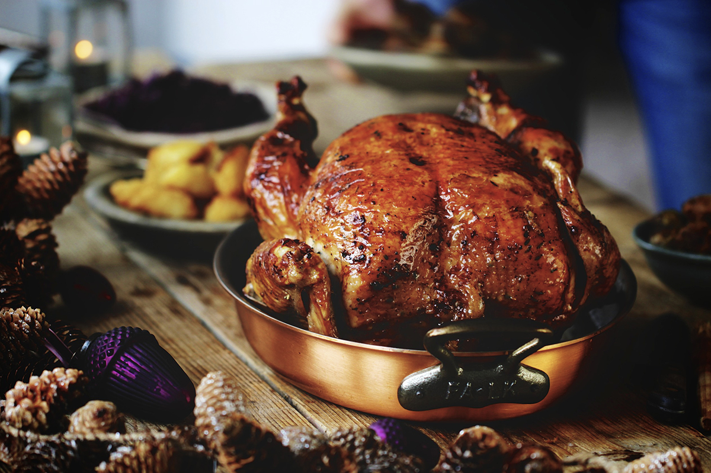

40cm Oval Gratin Pan

The versatile gratin pans are not just for lush crumb topped Dauphinois, but also make excellent roasting tins for the Christmas turkey. Each hand-finished vessel possesses the unique properties that set copper cookware in a league of its own.

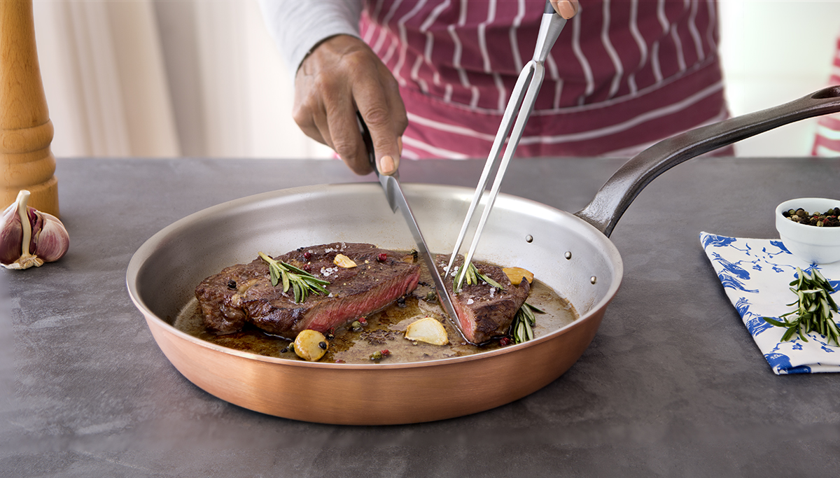

28cm Frying Pan

One of Falk Culinair’s most popular pieces, this frying pan offers the necessary surface area to height ratio that is spot on perfect for that Saturday night steak. With Falk bimetal, you will develop the confidence of the professional chef in the comfort of your own home.

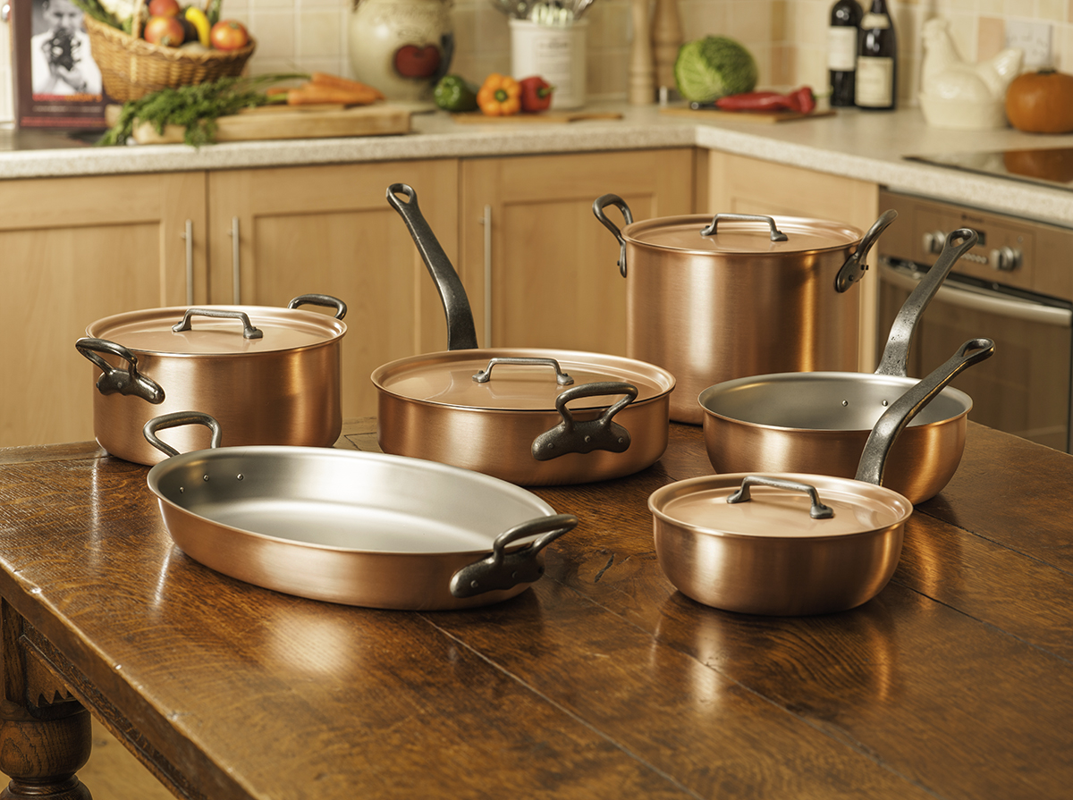

Falk Culinair Chef’s Set

Each of Falk’s durable, hard working sets has been designed in collaboration with professional chefs and cooking enthusiasts. The Chef’s set contains six select pieces with four lids to ensure all of your cookery needs are catered for. Ideal for family cooking, this comprehensive collection will be a delight for years to come.

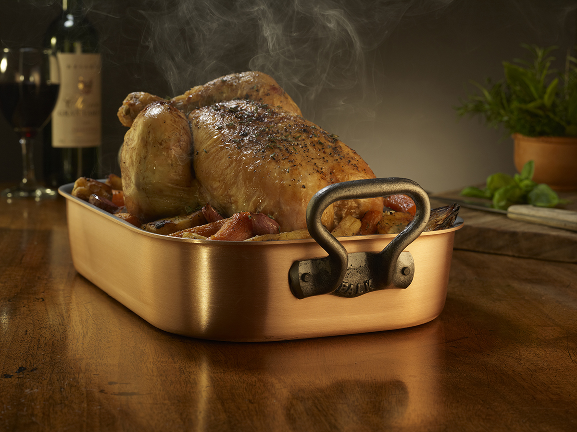

Copper Roasting Pan

Imagine a succulent chicken roasted to golden crispness with juicy, tender meat as well. Falk copper cookware conducts heat better than other materials used in cooking, and helps you regulate temperature accurately.

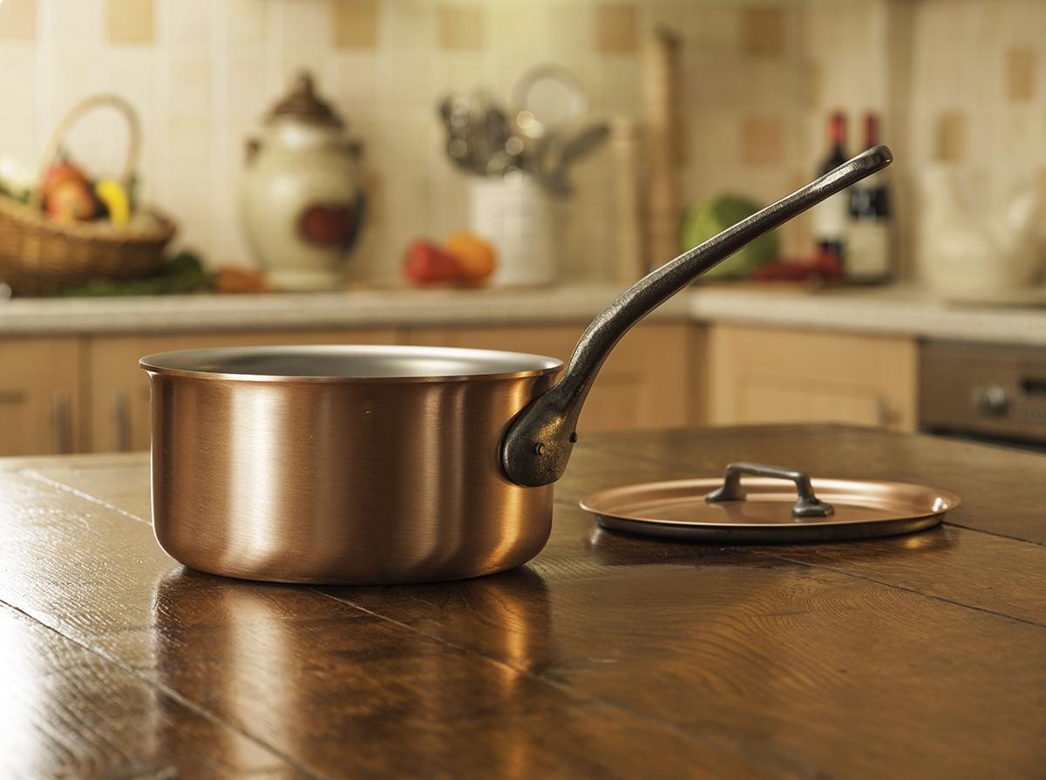

16cm Copper Saucepan

Falk’s bimetal construction takes the idea of a saucepan to a new level. As you may know, copper conducts and maintains het better than any other material used in cookware. We can’t promise you’ll be a better cook with Falk, but we can promise you will have better control over temperature and results.

0800 133 7560
www.falkculinair.co.uk/xmas

