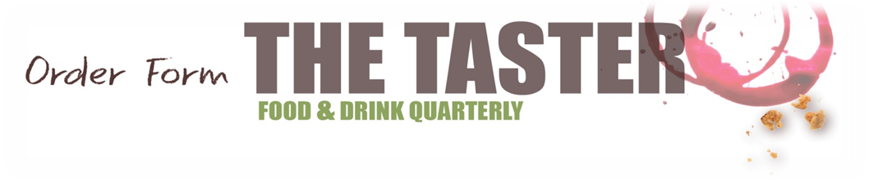
Please schedule this advertisement for publication in The Taster in  Christmas/Winter 2016 |  | ARTWORK  Please provide high-res PDFs with 3mm bleed & all marks; and JPG/TIFFs with at least 300dpi to:  thetastermagazine  @gmail.com
Account Manager: SUSAN QUAINE Ref: SQ1630
Artwork with order ◻ Design materials to follow 

I/We agree to pay the total sum of  £99  within 7 working days of today's date (9th November 2016)) to guarantee reservation of the space to fill (specified right) in the next issue of The Taster  Full Name: Neil Corke  Title: Managing Director  Signed:  Date: |  | DISPLAY SPACE TO FILL  (ie. full, half, quarter page; vertical/horizontal etc.)  ¼ page (Right Hand Side)  Entry in SHOPPING/EVENTS sections  (Similar to Classified Ad - specify text only or text & image)

DETAILS OF ADVERTISER

Company: Falk culinair UK
Address:,145-157 St. John's Street, London,EC1V 4PW

Tel: 0800 133 7560
Email: neil.corke@culinair.co.uk

Payment must be made before publication as described above by direct payment
to account 7345 8407, sort code 20-18-15

I/WE fully understand the conditions of this contract, acknowledge receipt of a copy and agree to supply either finished artwork, OR images and words to be prepared by our designer into a suitable artwork, along with the full balance of payment for the order, at least five working days ahead of the relevant press date. If artwork is not finished, we recommend that images and words are provided 5 working days ahead of the relevant press date. Repeat advertisements must be paid for together in the same way as a single advertisement. Deposits are not refundable: if the full balance of the order is not paid before the applicable press date, publication cannot be guaranteed. In the event of any payment being two months overdue the full outstanding balance of the order becomes immediately due. A voucher copy of the relevant issue will be provided by the publisher upon publication. Please see further T&Cs on page 2.
CatzPublications Limited is Registered Company No.8595325 in England & Wales. Mailing address: 14a Crescent Close, Cowbridge CF71 7EB

Terms & Conditions of CatzPublications Ltd

1. These conditions apply to all adverts accepted for publication. Any other proposed conditions must be agreed by both parties in writing.
2. All adverts are accepted subject to the Publisher's approval of the copy and to the space being available.
3. The Publisher reserves the right not to print an advert at any time for good reason.
4. Every care is taken to avoid mistakes, but the Publisher cannot accept liability for any errors due to third parties, subcontractors or inaccurate copy instructions or failure to provide particular fonts, images etc.
5. The Advertiser will indemnify the Publisher fully in respect of any claims made against the Publisher as a result of the advert.
6. Advertising rates are subject to change at any time without notice. Space already booked will not be affected.
7. If the Publisher undertakes to produce (including design and typesetting) an advert for the Advertiser, the Publisher will not be held responsible for any mistakes, errors or omissions, and the Advertiser agrees to pay any invoice submitted in full. Artwork prepared by the Publisher remains the property of the Publisher and cannot be used in other publications without the written (including via email) consent of the Publisher.
8. Cancellations will not be accepted, refunds will not be made and adverts booked in writing must be paid in full.
9. Amounts outstanding after the relevant press date will incur a surcharge of 10%.
10. All copy materials and cheques must be emailed to thetastermagazine@gmail.com or posted to The Taster, Cat Publications Ltd, 14a Crescent Close, Cowbridge CF71 7EB.
11. Commission will only be paid to recognised Advertising agencies and at the discretion of the Publisher.
12. Complaints regarding reproduction of adverts must be received in writing within 14 days of publication.
13. If full payment or copy is not supplied at least five working days before the relevant press date, no guarantee can be given that proofs will be supplied and the Publisher reserves the right to use the most appropriate available copy.
14. If, due to circumstances beyond the Publisher's control, changes to the format of the publication become necessary, the Publisher reserves the right to make any reasonable alterations or changes with prior reference to the Advertiser.
15. Any infringement in copyright concerning advertisements shall be the liability of the Advertiser.
16. In the event of the Advertiser selling, transferring or disposing of his/her business the new owner will be liable for any outstanding debts to the Publisher, and in the event of the Advertiser ceasing to trade he/she will be personally liable for any outstanding accounts to the Publisher.
17. For the purpose of these conditions, 'Advertiser' shall refer to the Advertiser, Buyer or his Agent, whichever is the principal. 'Advert' includes copy, loose or other 'inserts' where appropriate.
18. These conditions and all other express terms of the contract shall be governed in accordance with UK law.

Page 2
CatzPublications Limited is Registered Company No.8595325 in England & Wales. Mailing address: 14a Crescent Close, Cowbridge CF71 7EB

